Manu Patil

ISIM Fall 2018

16 October 2018

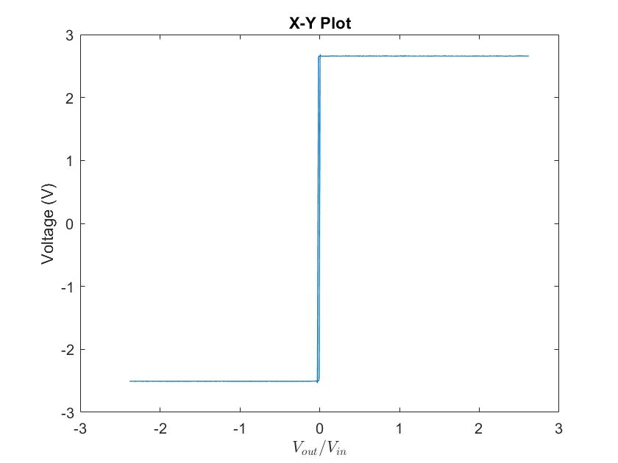

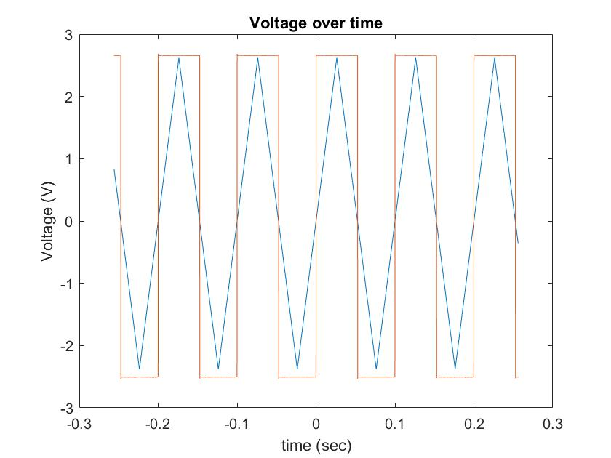

3. Yup the follower works as advertised. There is a slight delay, but

4. The Op- Amp struggles to keep up after 500 kHz and all of gives up after 1 MHz

5. The output is only positive as 0 in the lower end of the Op-Amps output

6. It takes around 2.82 µs to fully stabilize.

7. The positive feedback loop won’t work as a follower at with any slight fluctuation will cause the voltage to slam to one of the rails

1. Vout = 1.739 V
2. Vout = 2.55 V